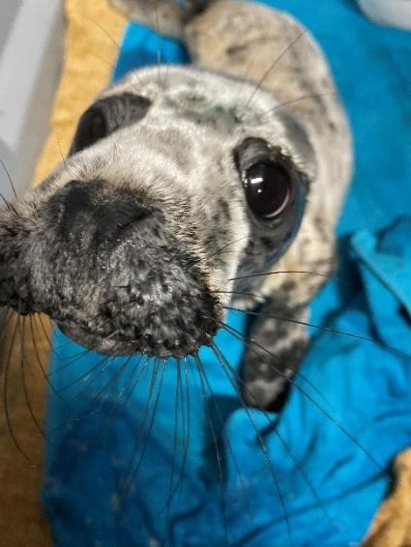

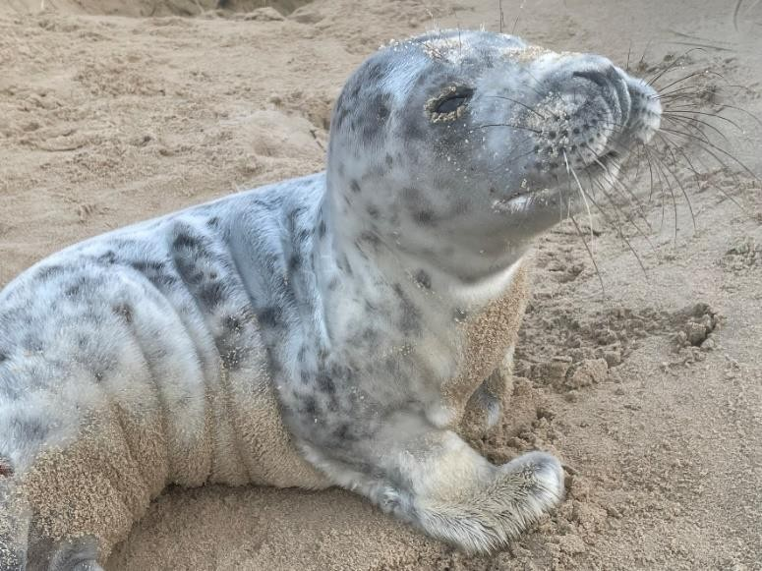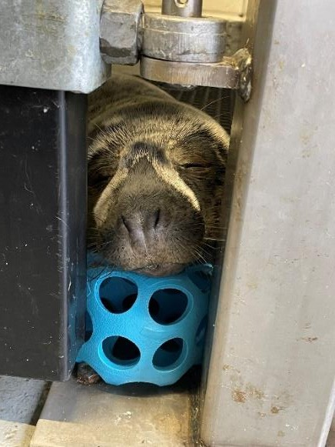Issue No.1

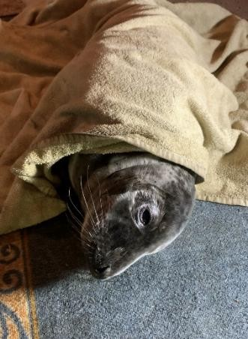
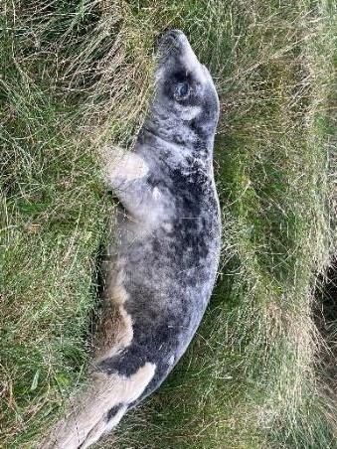
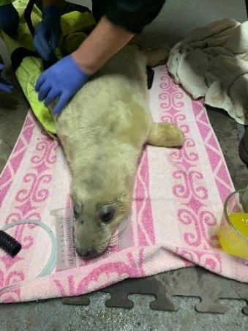
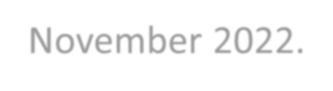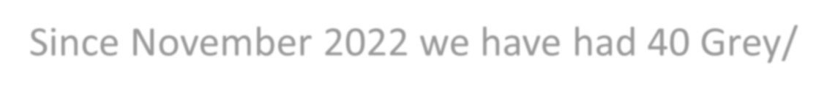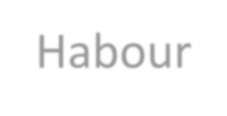
The hospital officially opened its doors on the 1st November 2022 and welcomed our first rescued Grey seal pup in on the 8th November 2022.
Since November 2022 we have had 40 Grey/Habour seal pups pass through our hospital doors. This figure includes the unfortunate souls that did not survive, whether that was through sickness or injury. Out of the 40 seal pups, 35 have successfully been released. That puts our release statistics at 87.5%
The four that were unfortunate not to survive , these seal pups arrived extremely unwell, and despite our efforts and hard work. The odds were against us.
The 2024/2025 season will start May/June with the arrival of any Common/Harbour seal pups we may get in. Let's hope our hard work and dedication will do these pups justice.

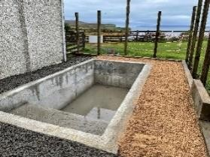
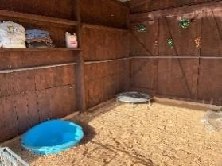
What has taken place in the hospital since the opening.
During 2023 we had some improvements made to the hospital which made it easier, safer and more hygienic for seals and volunteers.
The swimming pool that had originally been surrounded by sand and stone, is now surrounded
by a concrete floor which makes it a lot more hygienic and much easier to clean.
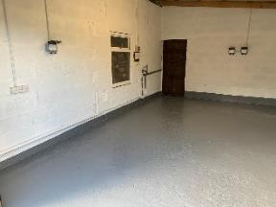
What was the sand pit, is now the food preparation room. The room was completely gutted, a concrete floor put down and heavy-duty vinyl floor laid. The walls are lined with wet boards for easy cleaning, a new window and door entry point was installed. There is a commercial freezer for storing all our fish. Stainless steel food preparation tables, a stainless-steel cupboard for storing supplies, new lighting and electric points.
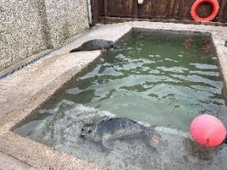
The ICU unit has had an upgrade, a new concrete floor with heavy duty vinyl laid. Wet boards
on all walls and new lighting.
The new building that was put up a while ago has a painted concrete floor, the walls are lined with wet boards, and four to six pens put up for the older, healthy seal pups. These pups then have 24hr access to the swimming pool.
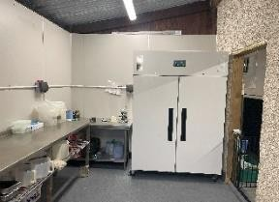
We received funding from the Stroupster Community Fund, Dounreay Community Fund and
from Animal Friends pet insurance.
During 2024 we are going to be building a new quarantine station, with three more pens. And a second swimming pool will be installed.
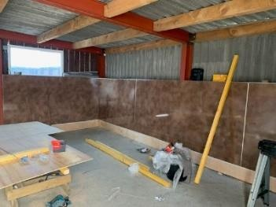
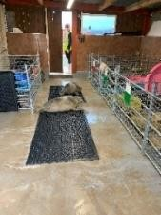
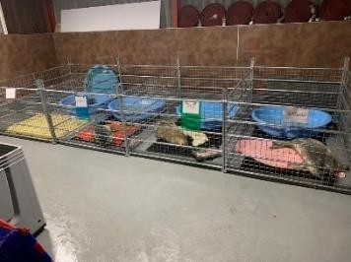
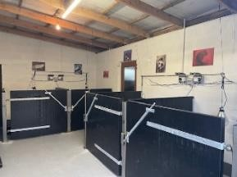

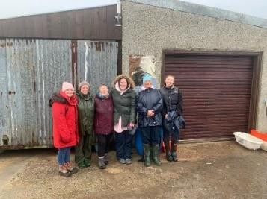
Our Volunteers
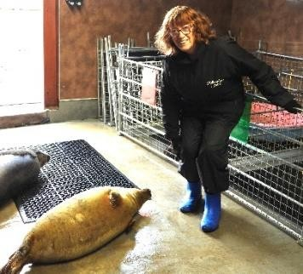
We have approximately 19 volunteers from all over our local Caithness & Sutherland communities. Each volunteer has varying levels of experience. Each volunteer gives as much time as they can, whether that's to look after the in-patients or out on call. And all their help is very much appreciated. One of our volunteers has been with us since we first started rescuing seal pups back in 2018.

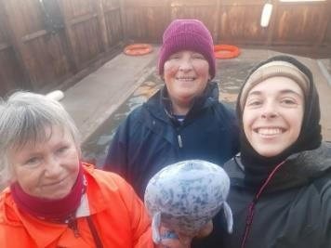
We have volunteers from Tain, Lybster, Canisbay, Dunnet, Brough, Thurso and Melvich.

Last year, 2023, during the grey pupping season, we had volunteers from Spain, France
and Columbia. Each volunteer from abroad came to learn about seal
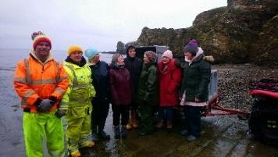
pups and the vital information about rehabilitation. During their stay they got to enjoy and explore Scotland, learn our language and meet new people. This is certainly something we will be continuing, and any interest is welcome.

This year, during the common pupping season, we have a couple coming from Switzerland and a
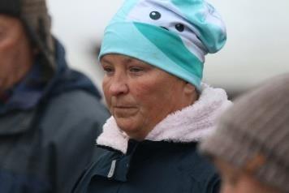
lady from the south of England.
During the grey pupping season, so far, we have a lady coming from Germany, and three ladies coming from Italy.

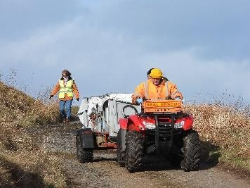
If anyone would like to volunteer, please get in touch. We ask that you can commit to at least two shifts per week, have your own transport, be able bodied as there is a lot of kneeling down and lifting heavy mats and paddling pools, and are over 18 years of age.

People wanting to volunteer from abroad, please get in touch for further details.

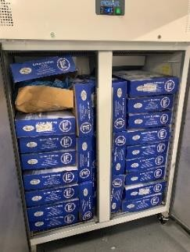
Fish, Feeding, Veterinary care & Other costs.

- Mackerel

Fish
- Herring
We buy all the mackerel that is needed, by the tonne.
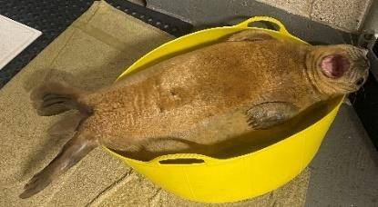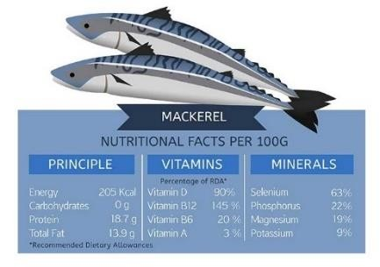We go through approximately 6 tonnes per year.
The herring is also bought in, this we buy by the box,
and go through about 3 tonnes.

- All

Veterinary Care
veterinary care
- Bloods
All our rescued seals are picked up and taken straight to the vets before arriving at the hospital. They get a thorough examination, and bloods are taken. They are then transported to the hospital where they are admitted. They are weighed, length measured, temperature is taken and given rehydration fluids.

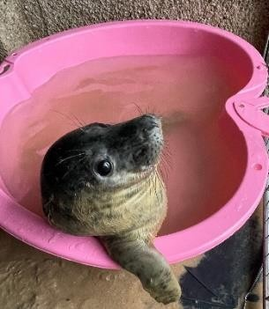
We go through an awful lot of disinfectant. The entire hospital is disinfected at least three times a day. We also go through quite a few paddling pools, unfortunately the pools cannot withstand the climbing in and out when the seal pups get bigger.!!

- Disinfectant
- Paddling Pools
- Hospital Improvements

Other Costs
Improvements have been made to the hospital during 2023.

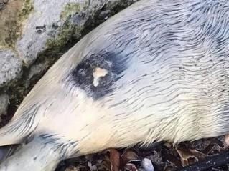
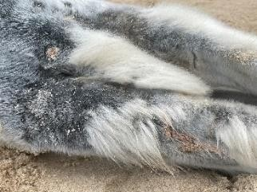
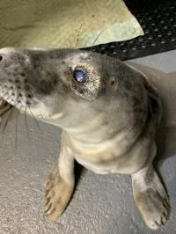
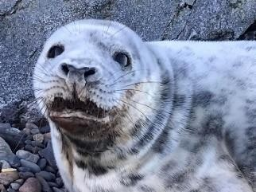
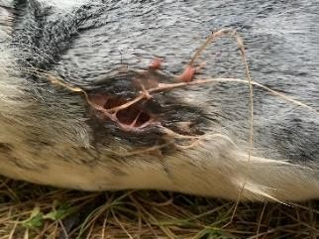
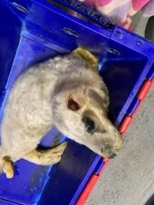

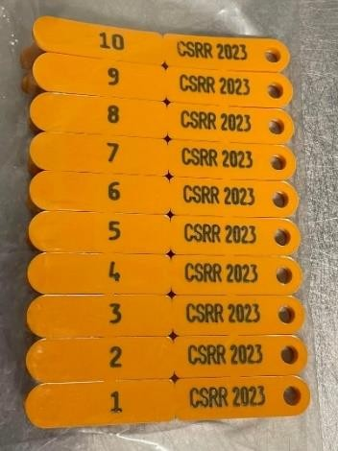
The release of our pups.
All our pups have been released down in Brough Bay which is just below the hospital. Brough Bay is a great place for releasing the seal pups as it is relatively calm on most days.
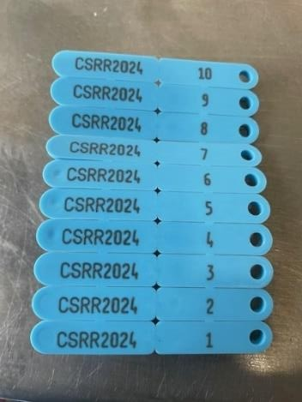
In 2022/2023 we released 12 grey seals, unfortunately none of which were tagged. In 2023 we released five common seals, all of which were tagged, and the orange tag is located on the rear flipper.
For the 2023/2024 season, we released 18 grey seals. They are all tagged with a blue tag located on the rear flipper.
To date, all pups released have left the bay. Mylo did stay in the bay for about four weeks before he left. Neave left the bay and returned 12 days later which was a fantastic surprise, she too has now gone. If you spot a seal hauled out with a tag on its rear flipper, please contact us immediately on 01847 851927, with its location.
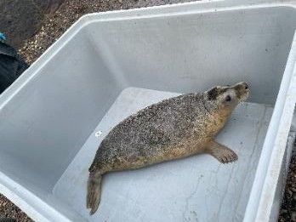
All the 2024/2025 common and grey seal pups will also be tagged. We are hoping to GPS tag a seal pup in the near future. In order for us to GPS tag a seal pup you need to work through a university or institute, there is a lot of red tape as it becomes research, and the GPS tags are very expensive ( In the region of £4000 -
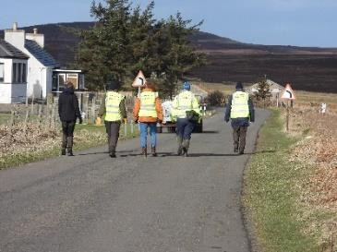
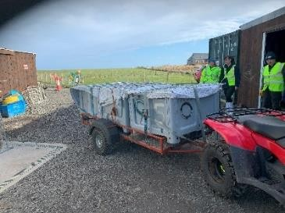
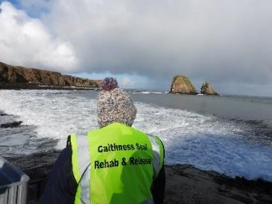
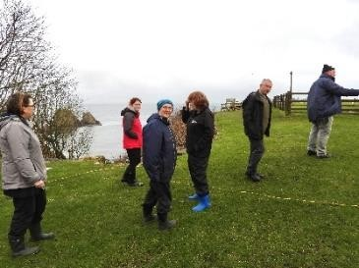
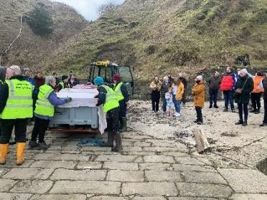
£6000 each).

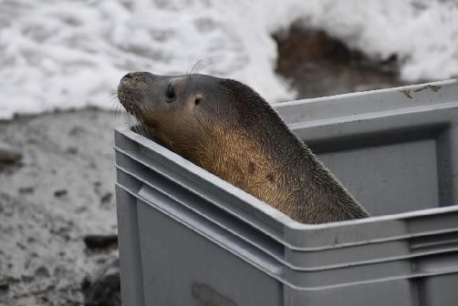
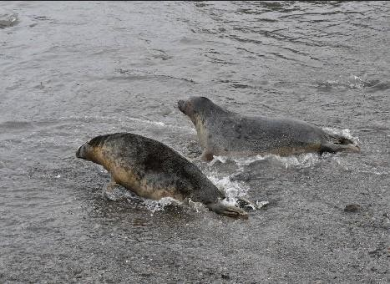
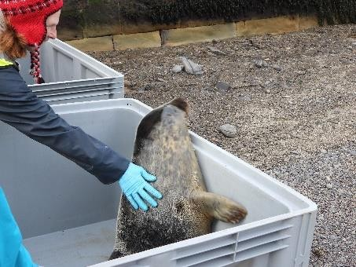
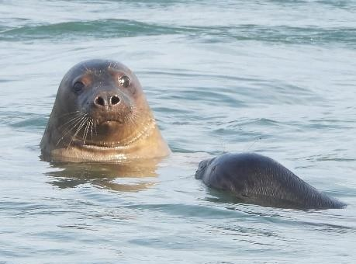
Our released pups

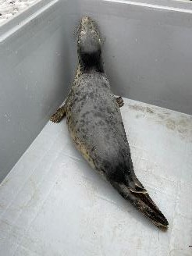
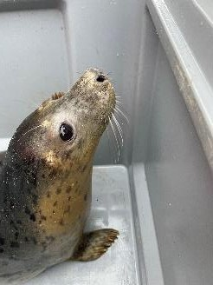
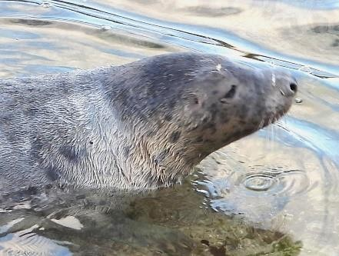
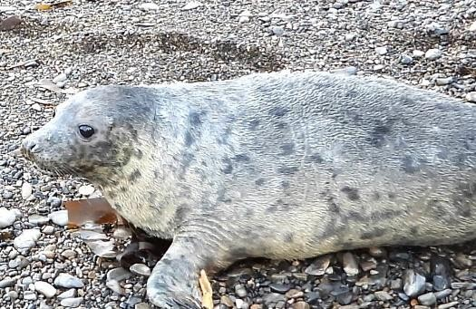
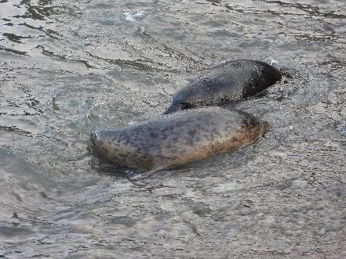

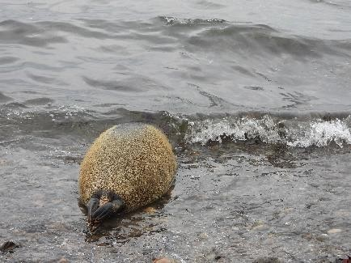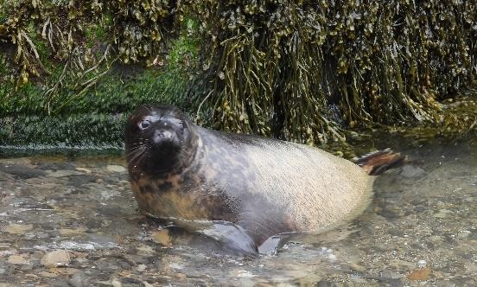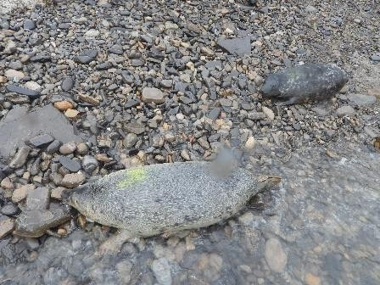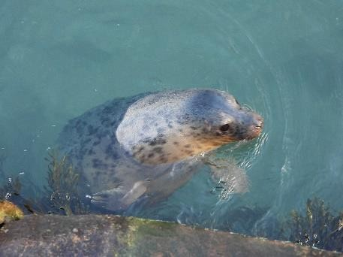
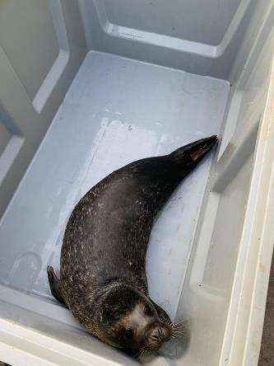
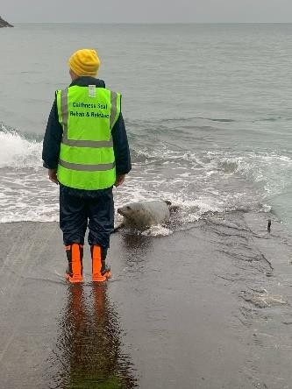
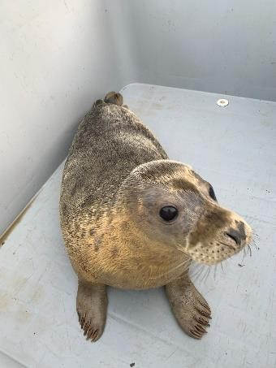
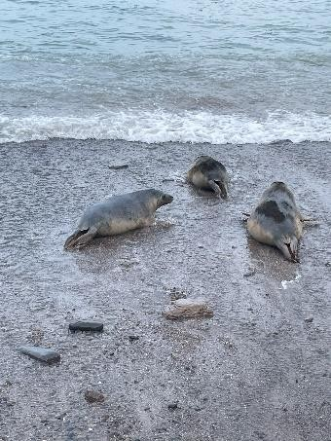
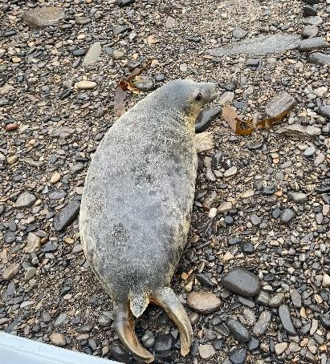

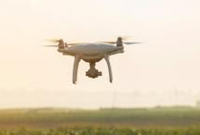
Threats to seals
Seal pup first-year survival rates are estimated to vary from 80 to 85% to below 50% depending on
location and conditions. Starvation, due to difficulties in learning to feed and stormy seas appears to be the main cause of pup death.

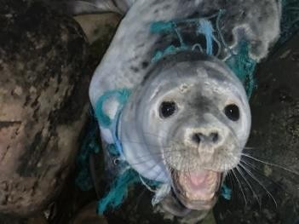
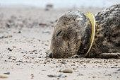
Another main cause of pup death is from human disturbance. Human disturbance is a threat we come across more frequently than we’d like to. Whether that’s because people want a photo, people just get too close, or people just do not understand. A seal pup needs distance between itself and the person, a minimum of at least 100m. If a seal or seal pup rears its head to look at you, you are too close. Especially if you are close enough to leave a scent on that pup. This becomes a problem, leaving your scent will more than likely influence that mother to abandon her pup. Pup death due to human interference is on the rise but you can help stop this. People should not touch a pup or move a pup. Do not chase it into the water. The pups white fluffy coat will become waterlogged, and they will drown.

Getting too close for a good picture or selfie is unacceptable.

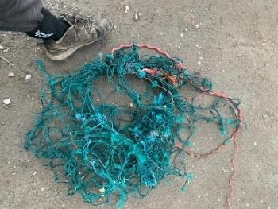
Another major concern are dog attacks. We are seeing an increasing number of pups coming in that have been attacked and bitten by dogs. If you are going down to a beach during pupping season and you know pups will be there, keep your dog on a lead, no matter how well behaved the dog is.

People flying drones to low over colonies of seals with pups is also of concern. The noise scares the seals that are hauled out, causing a stampede where pups are either killed or lost whilst trying to get away.

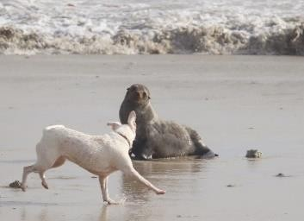
We are seeing an increase in numbers injured or even, deceased seals, with flying frisbee’s embedded around their neck. We can avoid this by using solid rings with our dogs and families when visiting beaches.

Marine waste. Seals get caught up in discarded fishing gear and nets. Tougher laws need to be
enforced with regards to discarding fishing gear into the sea.

What to do if you see a pup on the beach

DO NOT get too close no matter the circumstances, even for a selfie, stay AT LEAST 100 meters away.

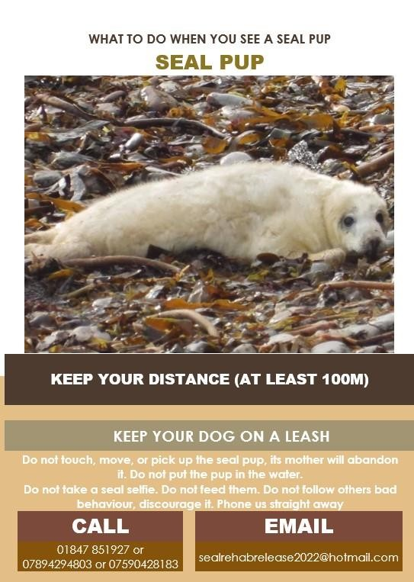
Check to see if the pup's mother is around, be careful, she will charge for you if you are too close to her pup.

DO NOT pick the pup up, touch it or move it, once you have left your smell, the mother will abandon the pup.

DO NOT put the seal pup back in the water or DO NOT chase it into the water. A white coat pups coat
gets water-logged, and it will drown.

DO NOT attempt to feed it, they are wild animals and they will bite you.

DO NOT follow others bad behavior, discourage it. If you are worried about a seal pup's welfare, take pictures or a video and contact us immediately.
__

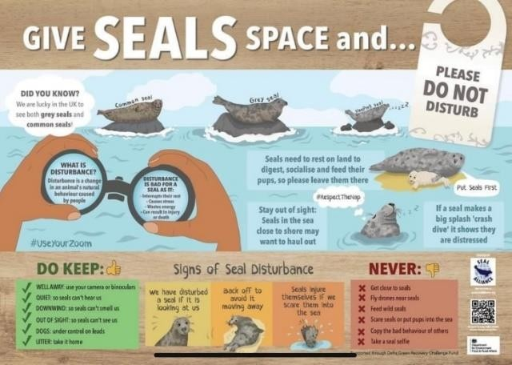
MAKE SURE your dog is on a leash, no matter how well behaved you believe it to be.

DO observe from a distance, only if the mother is definitely not around.

DO make a visual note, from a distance, of the seal pups' behavior. Does it look unwell, is it injured, does it have a white coat and is it very small.?

DO make a note of your location, using “What Three Words” is the best, or pin it on Google
maps.

DO ring us straight away. We will get one of our experienced volunteers out to assess the seal pup and pick it up if necessary.

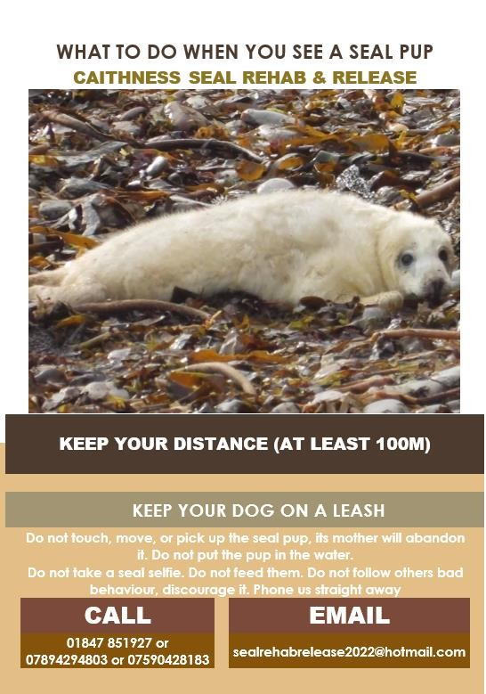

Useful Numbers

Hospital Landline: 01847 851927.

Mobile: 07894294803 or 07590428183.

Message us on Facebook Messenger or on WhatsApp. Send us an email: sealrehabrelease2022@hotmail.com

You can also call the SSPCA on 03000 999 999 or Call BDMLR on 018250765546.

Any dead cetaceans, including seals, can be reported to SMASS on
07979245893.

Notes

