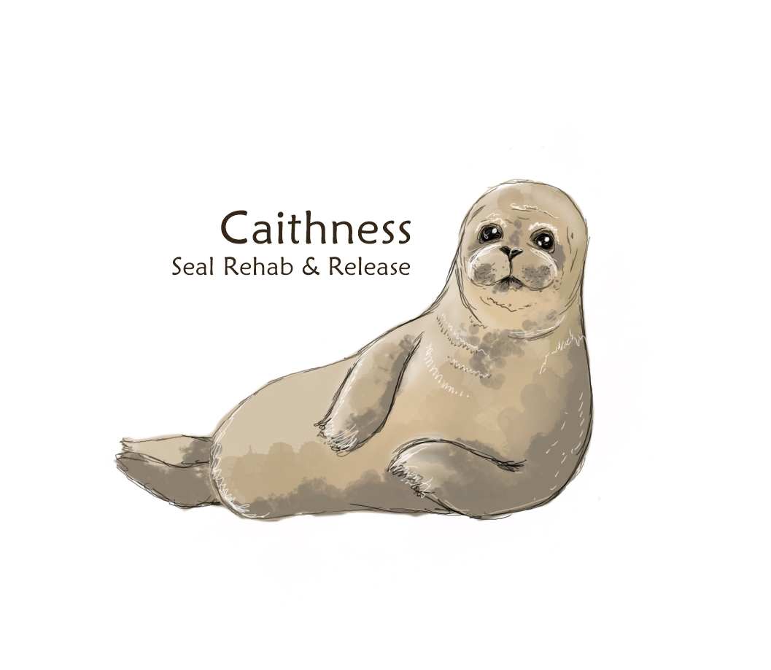

Charity Donation Form

Please complete all sections of this form. If you wish to donate anonymously, please make your donation by bank transfer and leave the 'Contact information' section blank.

Your donation will help fund all the seal pups in our care from arrival to release date. Thank you for your generous support!

Contact Information

Full Name Company (if any)

Address

Address

City County Post code

Donation Amount

£5
£10
£20
£25
£30
Other amount

Weekly _____ Monthly ____ Once off ____

Payment Information

Bank Transfer/BACS

Cheque

Signature Date ______________________
Print name ___________________________________________
Email: sealrehabrelease2022@hotmail.com

Send completed donation forms via email or post:

POST: Caithness Seal Rehab & Release

Windhaven, Brough, Caithness, KW14 8YE

Banking details: Caithness Seal Rehab & Release
Account No: 00613585
Sort Code: 83-25-06
Please make cheques out to Caithness Seal Rehab & Release

